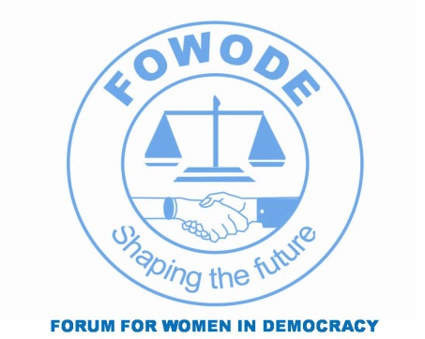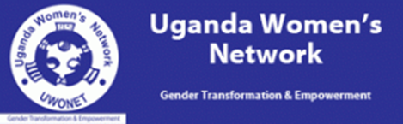
3rd WOMENS THINK TANK MEETING
28th March 2014

Hotel Africana.

8:00am – 8:30am |  | ARRIVAL AND REGISTRATION
8:30 am - 9:00 am |  | Welcome Remarks | Executive Director  Forum For Women in Democracy (FOWODE)
9:00am - 10:30 am |  | Panel: The current governance issue and their implications to women in Uganda | Panelists  - Dr. Stella Nyanzi- MISR.  - Mr. Gwadda Okot- CCEDU  - Ms. Rita Aciro - UWONET
10:30-11:30 am |  | Health Break
11:30am – 12:15 pm |  | Voice, Standpoint and Accountability to Women. | - Mr. Leonard Okello.  - Ms. Norah Matovu.  - Ms. Perry Aritua -WDN
12:15 - 1:00 pm |  | Going Forward
 |  | LUNCH AND DEPARTURE AT WILL

